

**Lab Manual**

### Subject: Machine Learning

#### Course Code AI-414

### By

#### Mohammad Mukedas 2023-BS-AI-008

#### Supervised by Sir Saeed Degree name: BSAI-4A



##### DEPARTMENT OF COMPUTATIONAL SCIENCE

**Table Of Content**

**Project 1:Paris Housing Price Prediction 3**

1. Data Collection: 3

2. Data Preprocessing: 3

3. Feature Selection: 3

4. Model Training (Linear Regression): 3

5. Prediction: 4

6. Expected Output: 4

Program: 4

**Project 2: Mushroom Classification Using Classifier** 13

Program: 14

**Project 1**:**Paris Housing Price Prediction**

## Description:

This project involves predicting the **price of houses in Paris** using a **regression algorithm**. The dataset includes features like the number of rooms, size (square meters), floors, and location details. These features are used to train a **Linear Regression model** that can estimate the price of a house.

## Tools & Technologies:

* Python
* Pandas, NumPy (for data handling)
* Scikit-learn (for regression models)
* **Matplotlib / Seaborn** – for data visualization (optional but useful)

## How It Works:

## Data Collection:

## Load the Paris Housing Dataset containing real estate features and prices.

## Data Preprocessing:

## Handle missing values (if any)

## Normalize or scale the data if needed

## Convert categorical data (if present) into numeric form

## Feature Selection:

## Use columns like:

## Number of rooms

## Square meters

## Floors

## District/location info

## Model Training (Linear Regression):

## Train a Linear Regression model using the training data to learn the relationship between features and house prices.

## Prediction:

## Test the model using unseen data to predict house prices based on input features.

## Expected Output:

## The system will accurately predict the price of houses in Paris when provided with features like area, rooms, and location details. The output will be a continuous value (price in Euros).

**Program:**

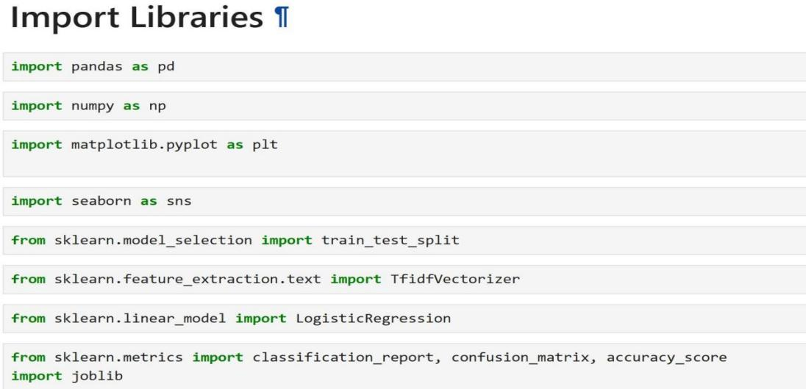

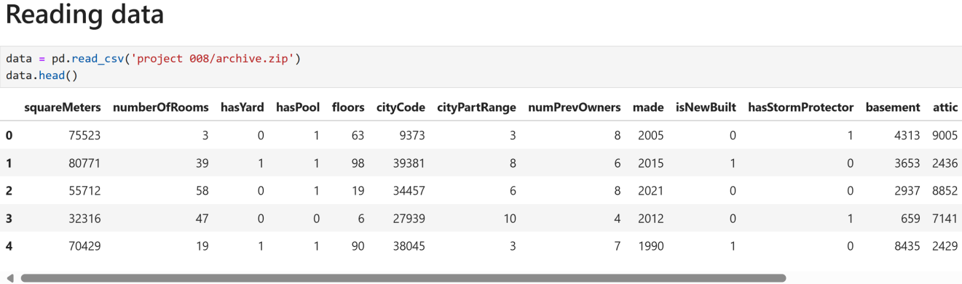

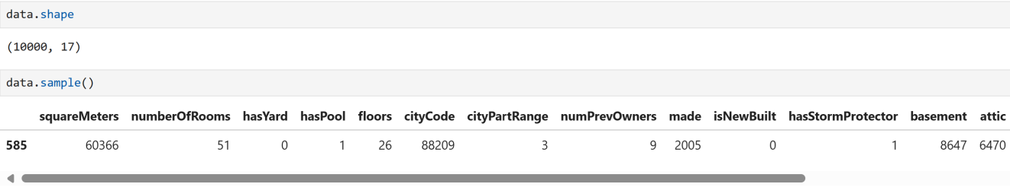

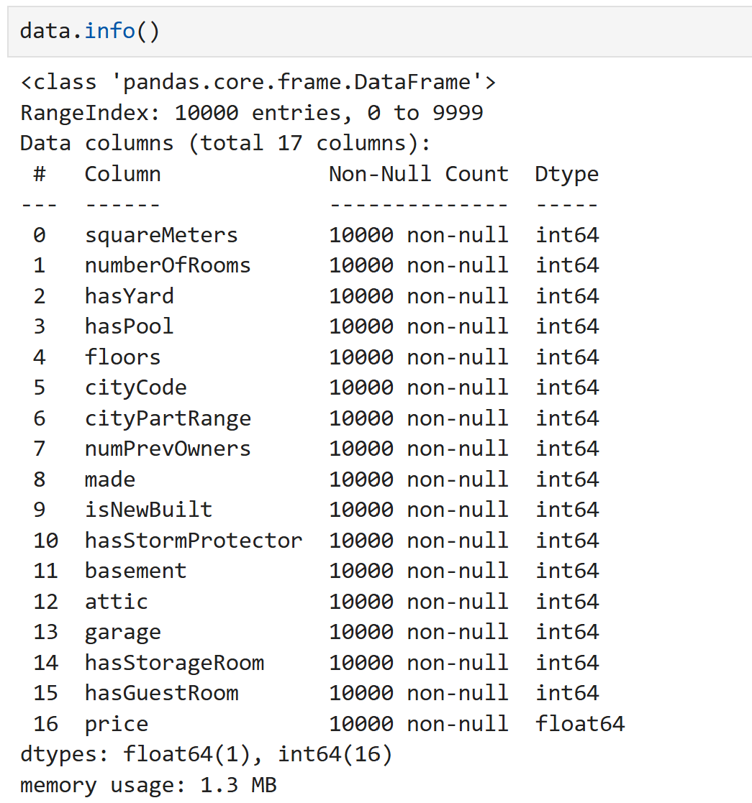

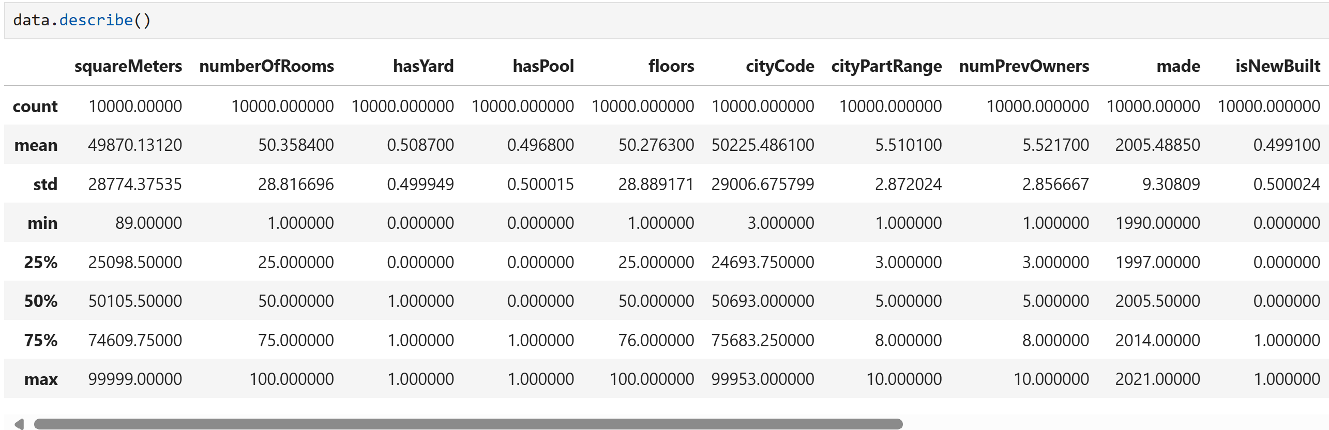

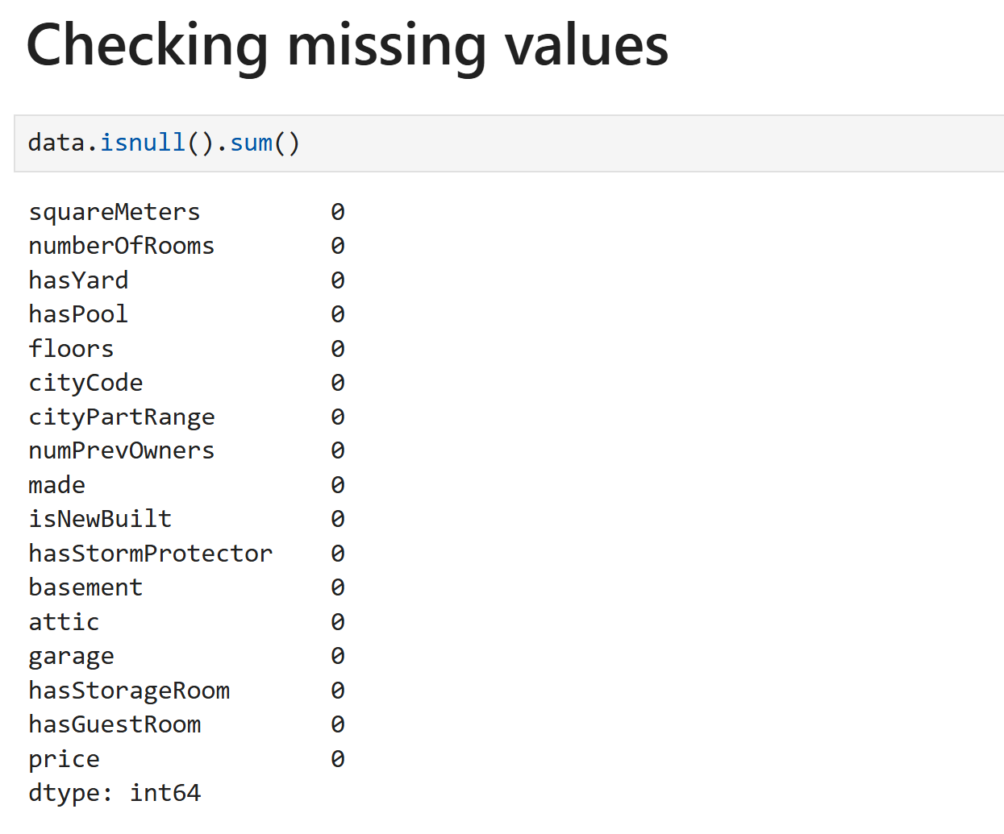

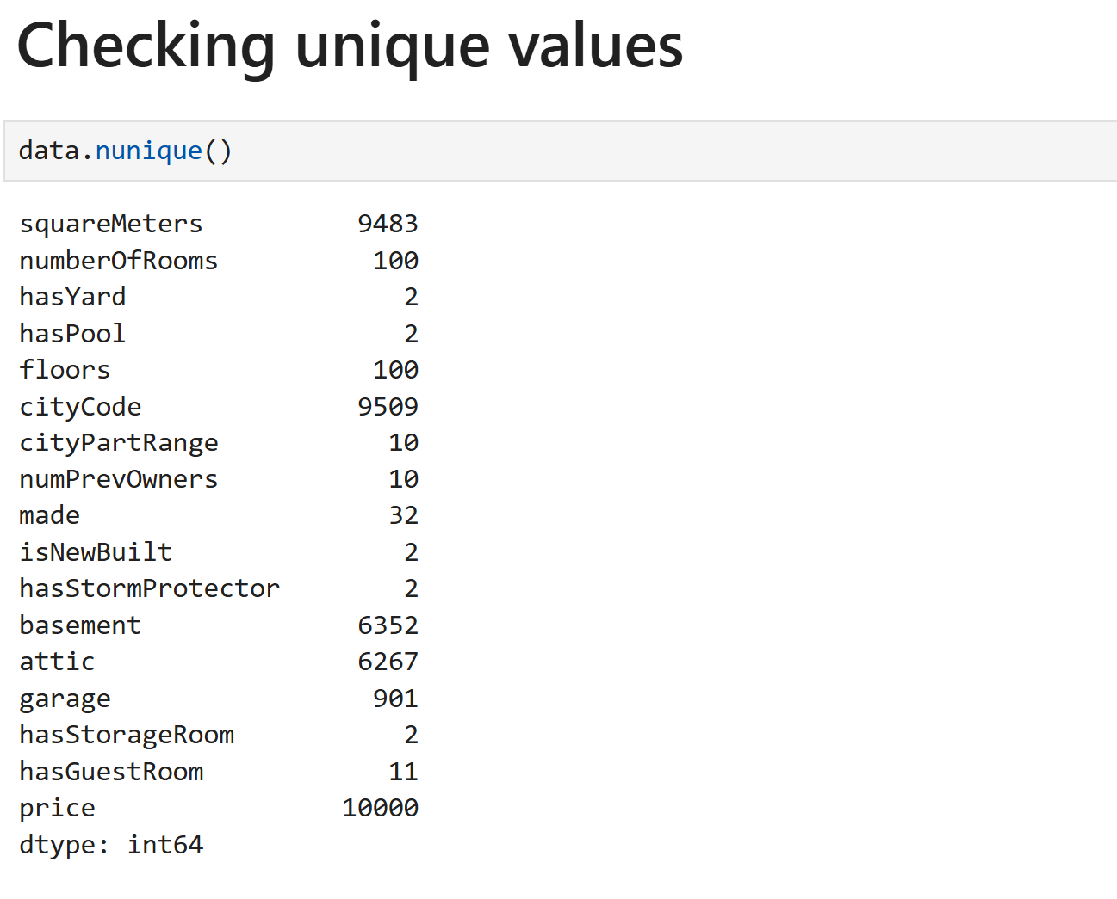

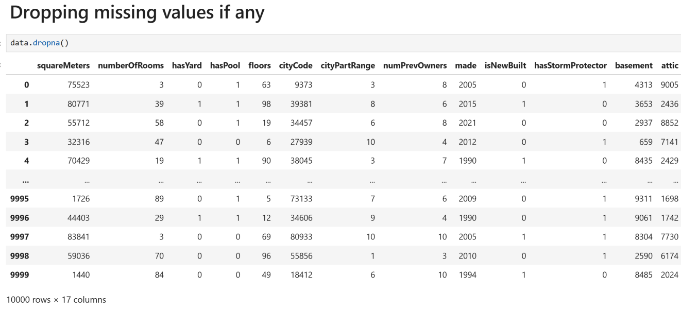

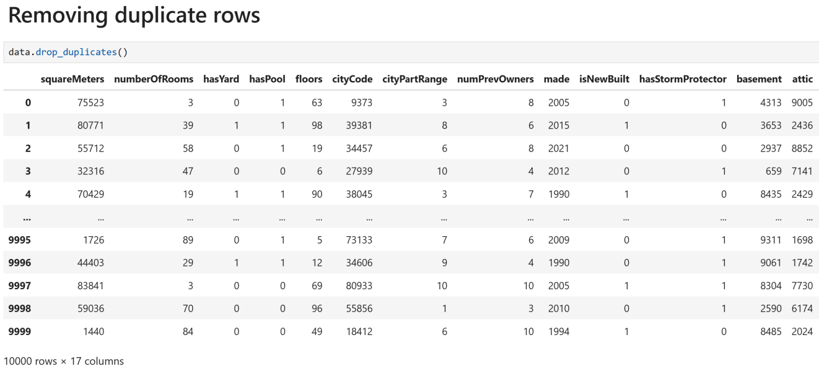

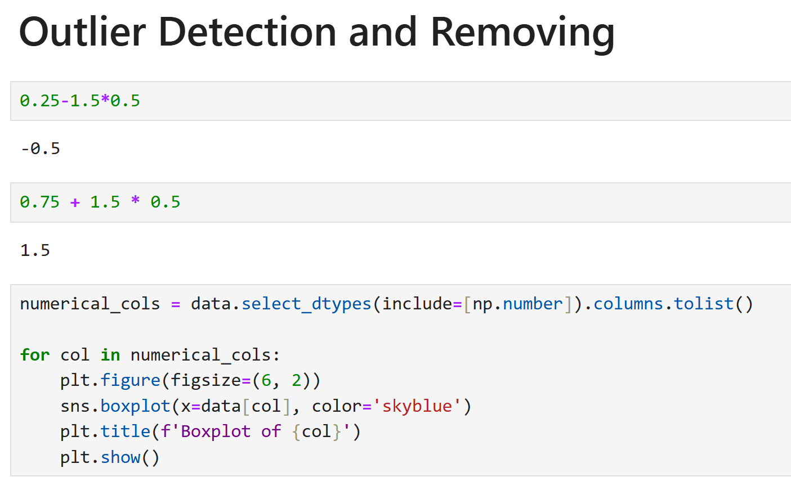

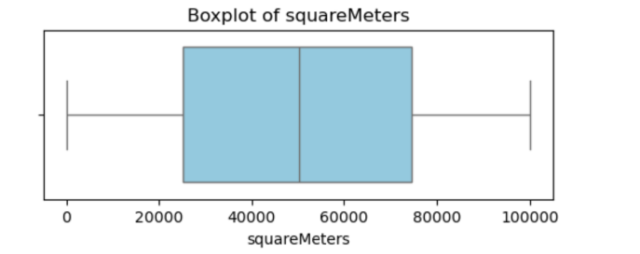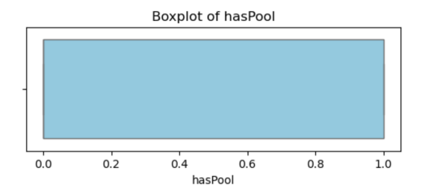

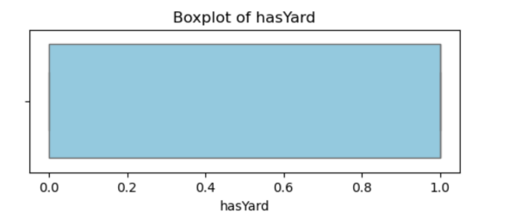

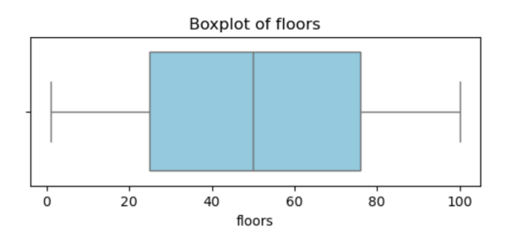

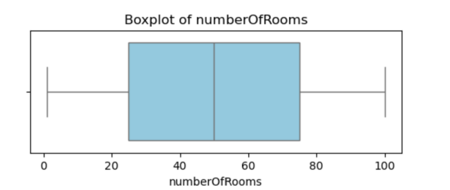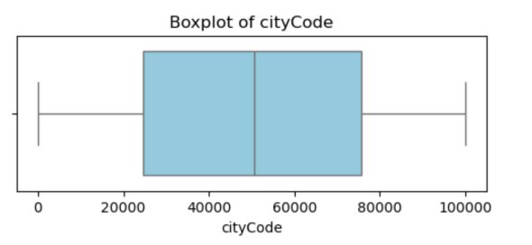

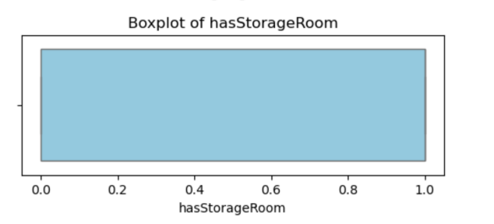

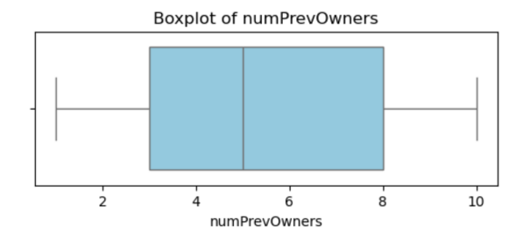

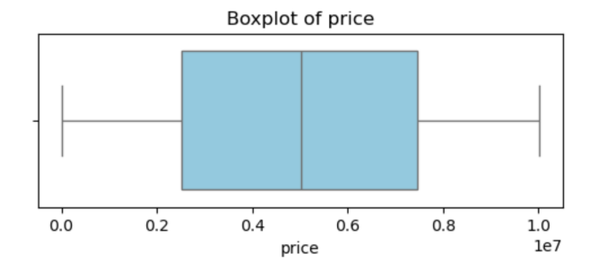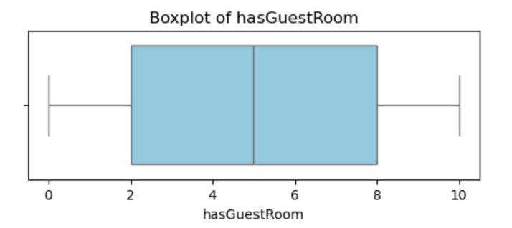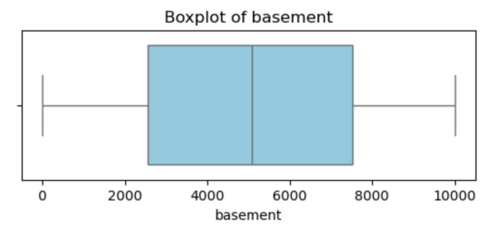

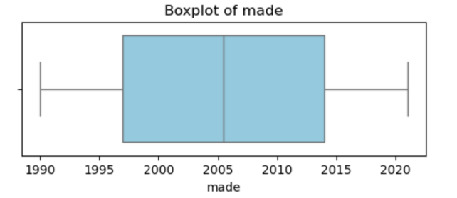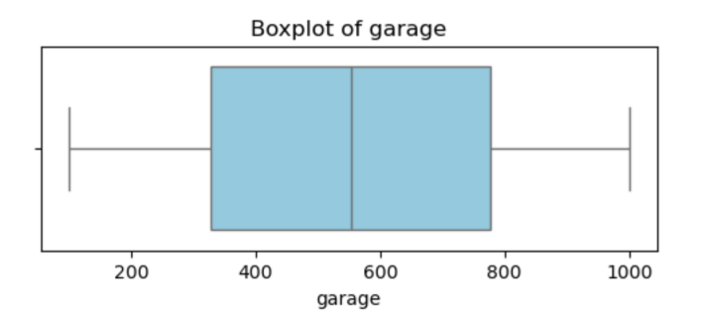

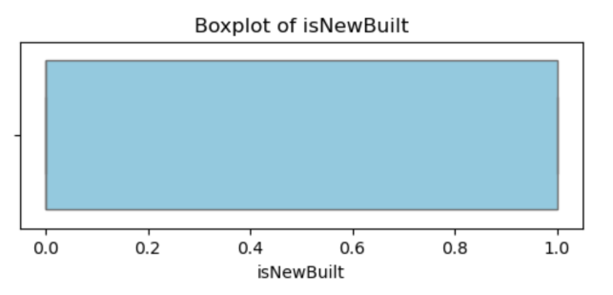

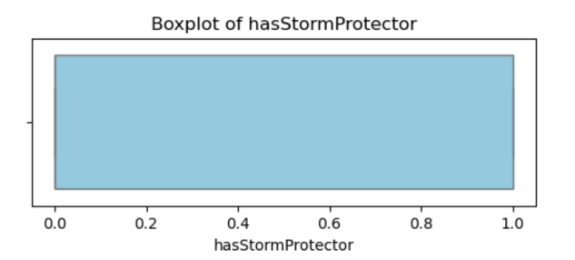

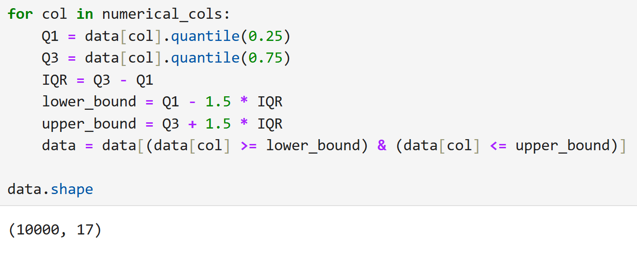

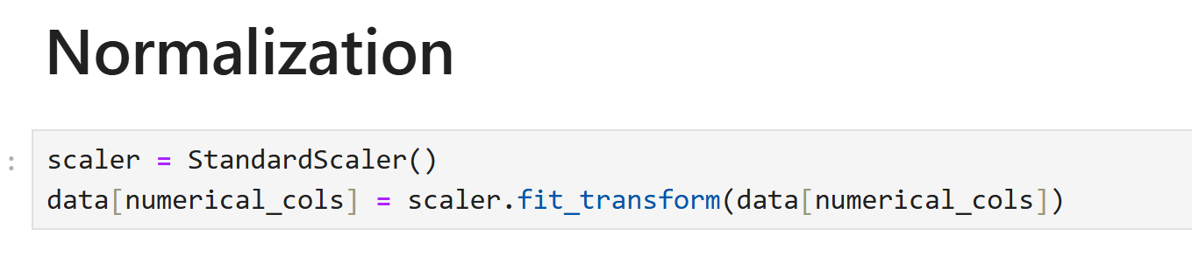

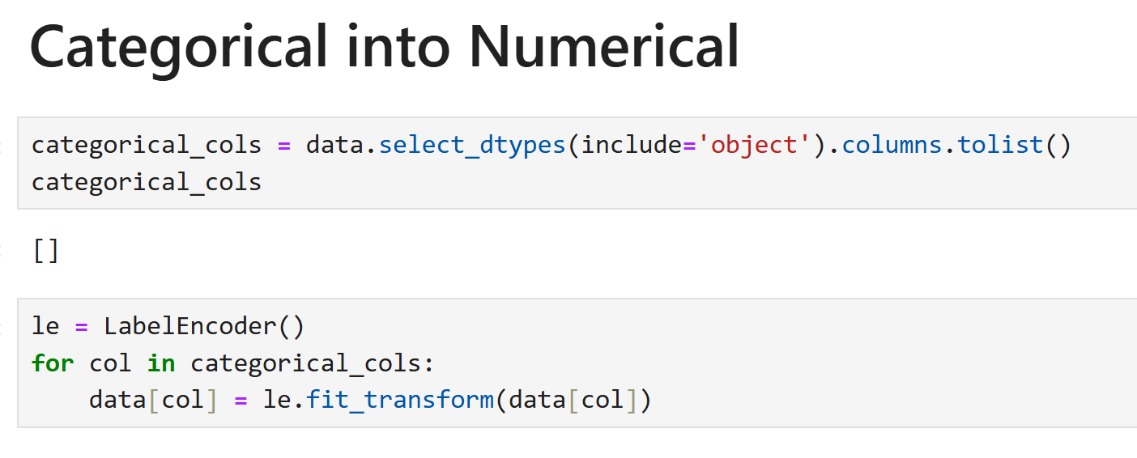

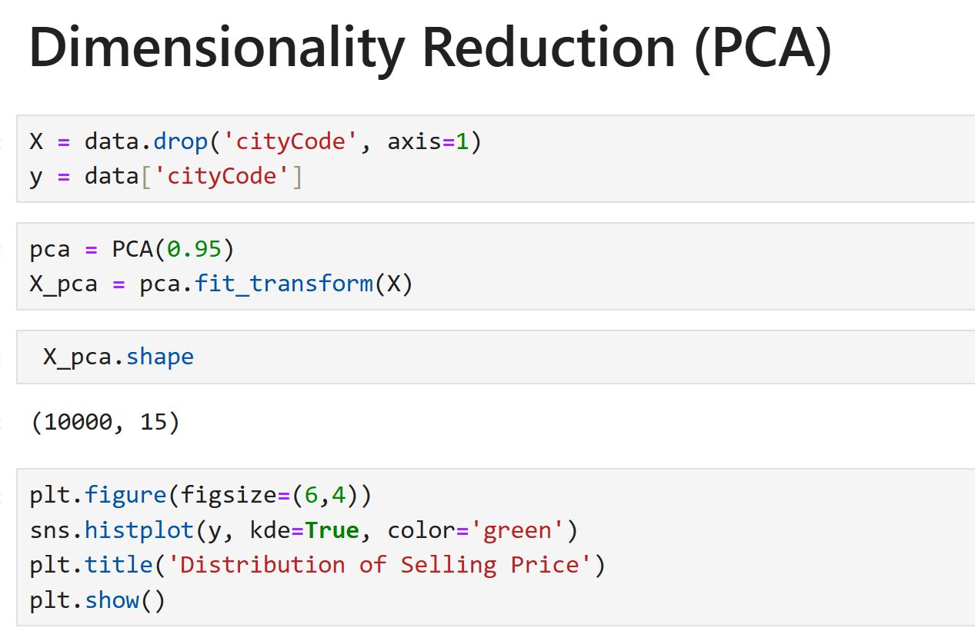

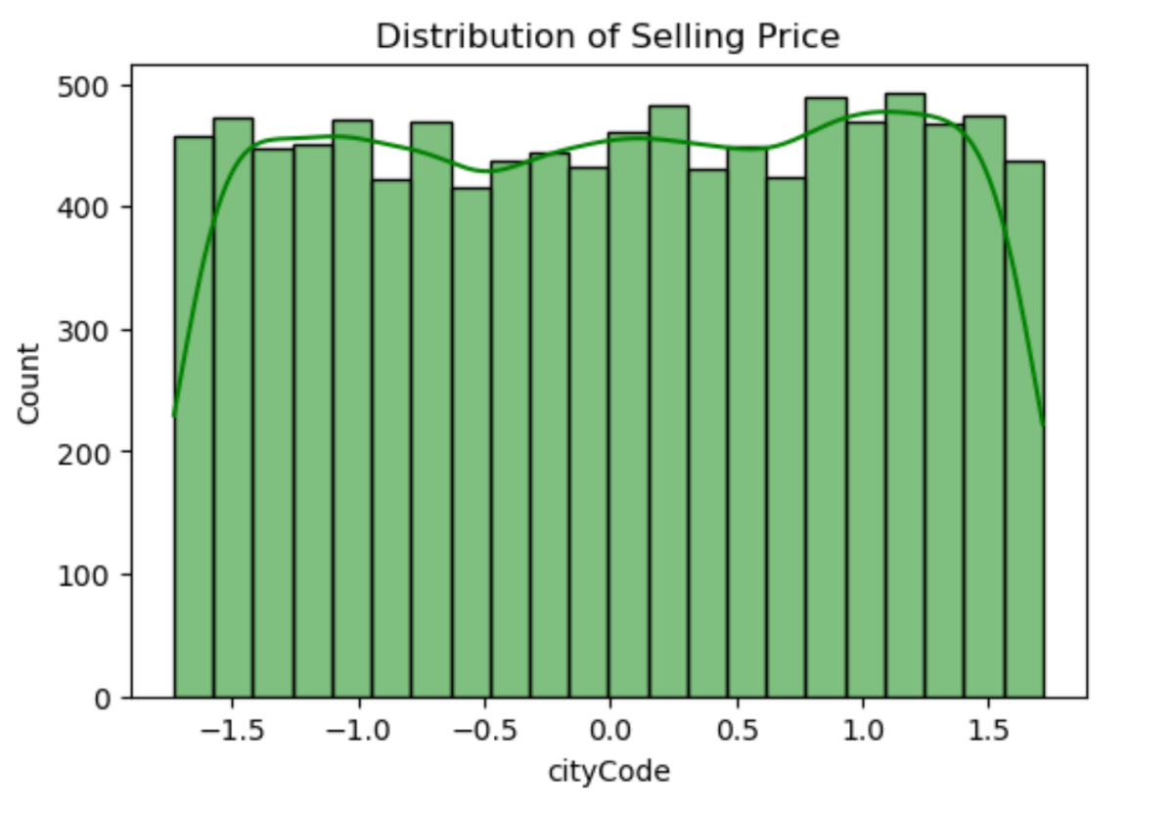

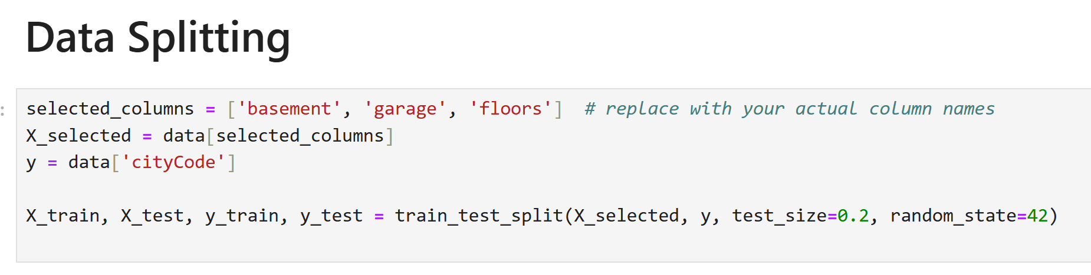

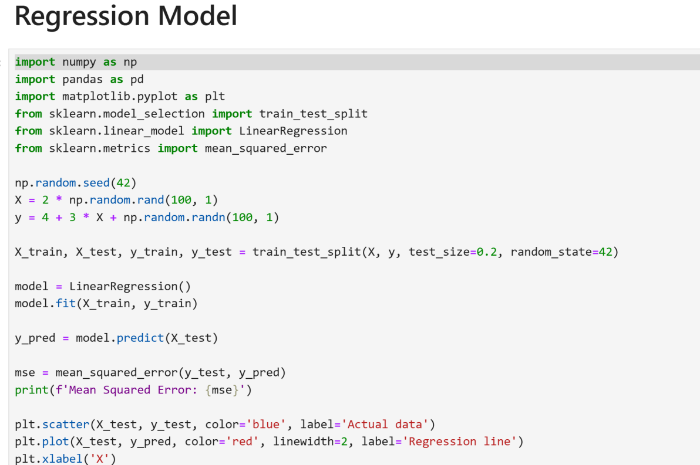

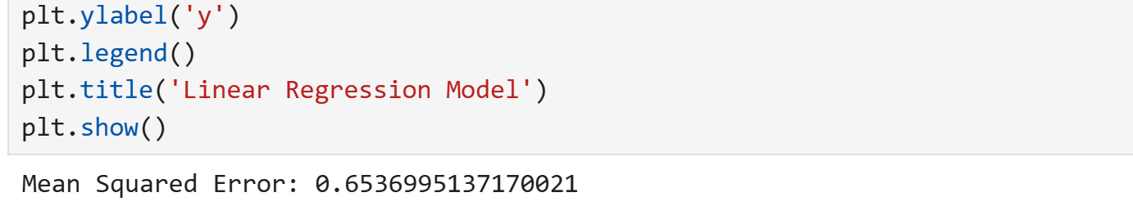

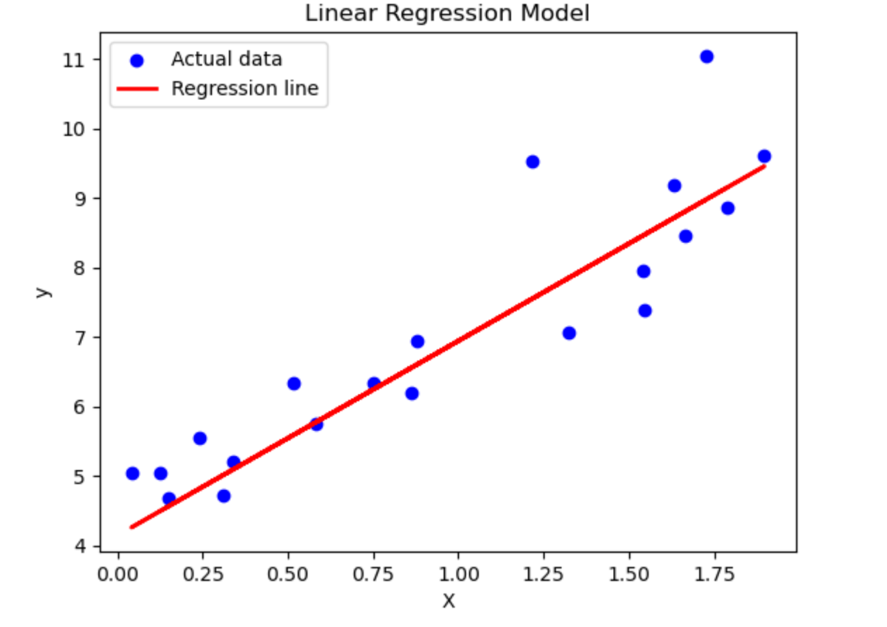

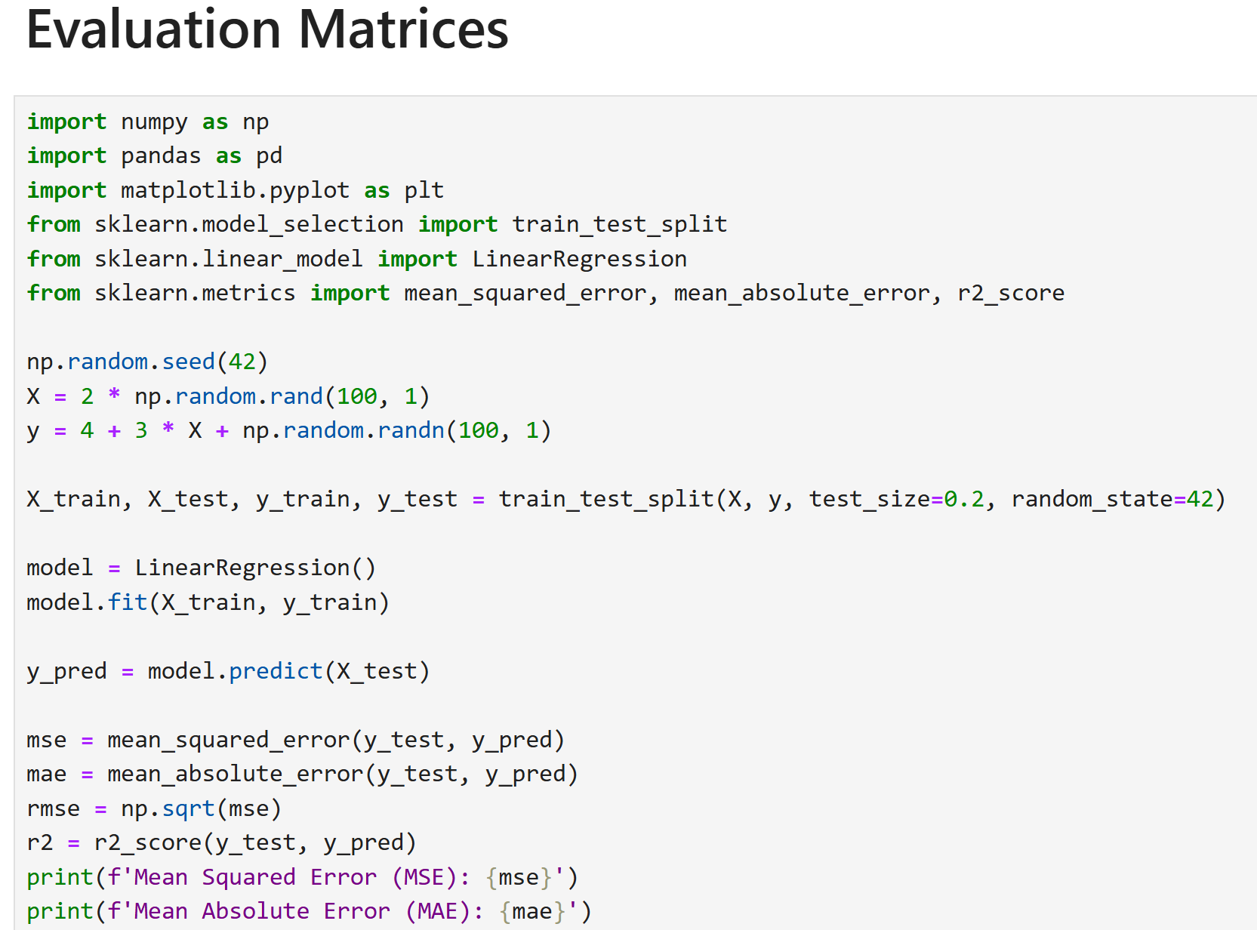

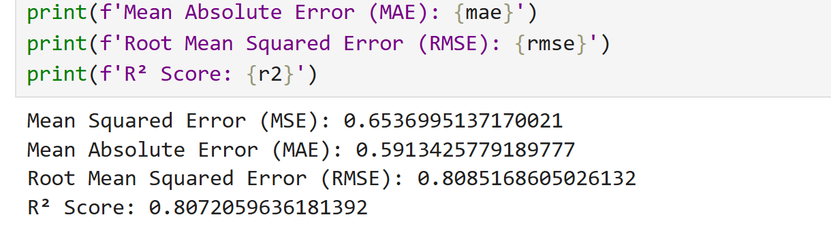

# Project 2: Mushroom Classification Using Classifier

## Introduction:

In this project, we will examine the data and build

different **machine learning models** that will detect if the mushroom is **edible or poisonous** by its specifications like cap shape, cap color, gill color, etc. using different classifiers.

## Dataset:

The dataset used in this project is that contains 8124 instances of mushrooms with 23 features like cap-shape, cap-surface, cap-color, bruises, odor, etc.

The **python libraries** and packages we’ll use in this project are namely:

* NumPy
* Pandas
* Seaborn
* Matplotlib
* Graphviz
* Scikit-learn

We’ll use the specifications like cap shape, cap color, gill color, etc. to classify the mushrooms into edible and poisonous.

**Program:**

